**System Design**

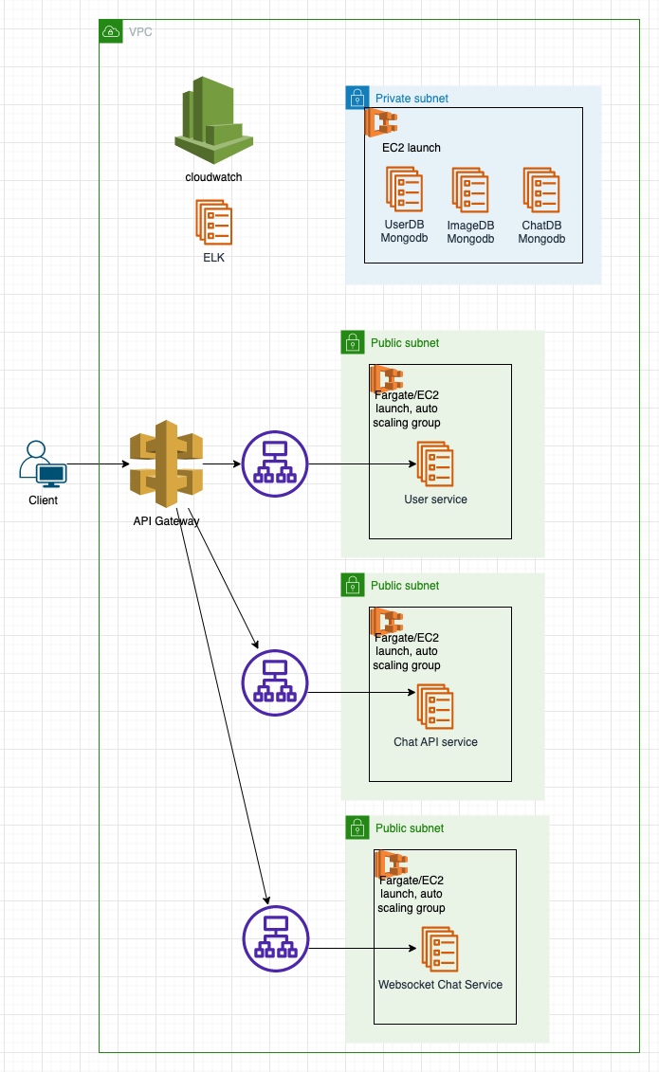

I will design this system base on dockersize. So the services can host on any cloud support docker (ECS, EKS, K8s, ...) or self host.

Regarding user service, used for user to register/login/auth/logout.

Regarding Chat API service, Image/Document and its data (document url, coordinate of anotations) will be store in ImageDB.

Regarding Websocket Chat Service will be use for managed connection and realtime comunications. If client of the topic doesn’t connected so the message will be send by any services.(SNS, APNS, FCM, PushNub, Onesignal, ...).

For systems logs i will use cloudwatch and ELK for monitoring.

Techstack:

- Typescript.

- NestJS: <https://nestjs.com/>

- Docker.

- MongoDB.

- SocketIO: <https://socket.io/>

- ELK: <https://www.elastic.co/what-is/elk-stack>